**Exercise 2: Implementing the Factory Method Pattern**

**Scenario:**

You are developing a document management system that needs to create different types of documents (e.g., Word, PDF, Excel). Use the Factory Method Pattern to achieve this.

**Steps:**

1. **Create a New Java Project:**
   * Create a new Java project named **FactoryMethodPatternExample**.
2. **Define Document Classes:**
   * Create interfaces or abstract classes for different document types such as **WordDocument**, **PdfDocument**, and **ExcelDocument**.
3. **Create Concrete Document Classes:**
   * Implement concrete classes for each document type that implements or extends the above interfaces or abstract classes.
4. **Implement the Factory Method:**
   * Create an abstract class **DocumentFactory** with a method **createDocument()**.
   * Create concrete factory classes for each document type that extends DocumentFactory and implements the **createDocument()** method.
5. **Test the Factory Method Implementation:**
   * Create a test class to demonstrate the creation of different document types using the factory method.

**OUTPUT:**

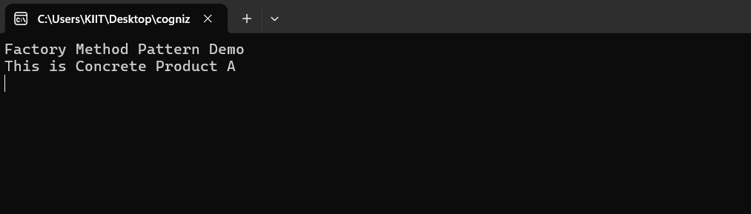

**CODE:**

**Program.cs**

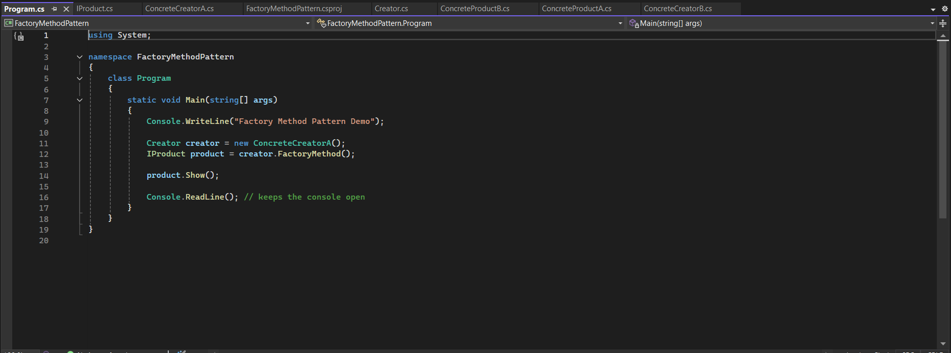

**IProduct.cs**

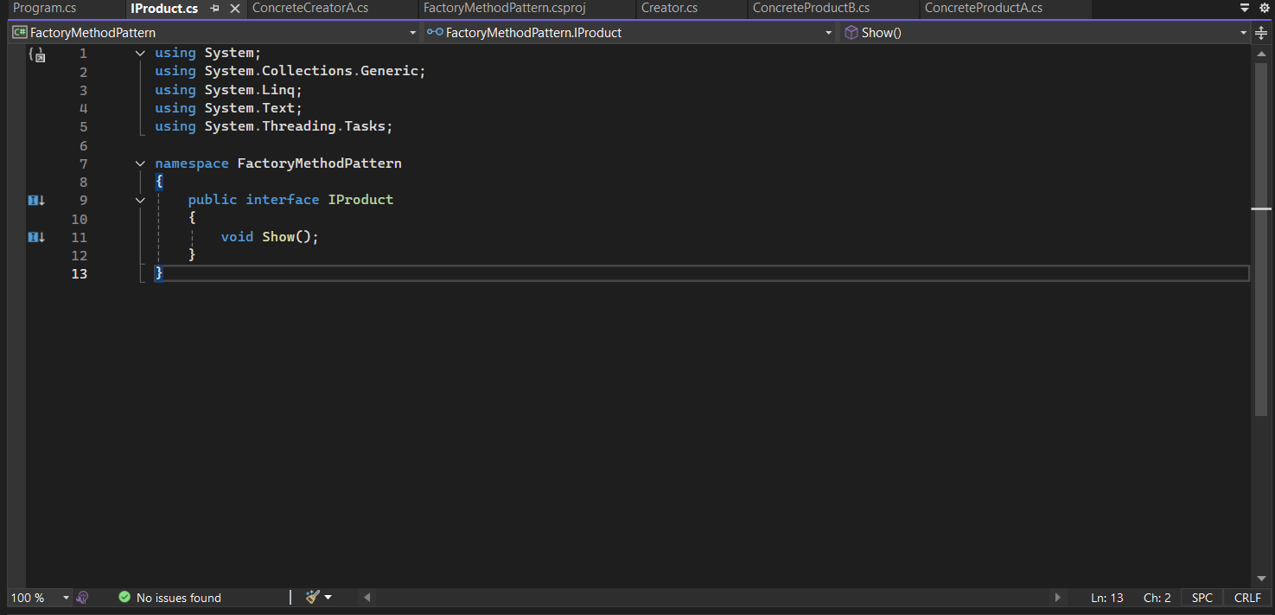

**Creator.cs**

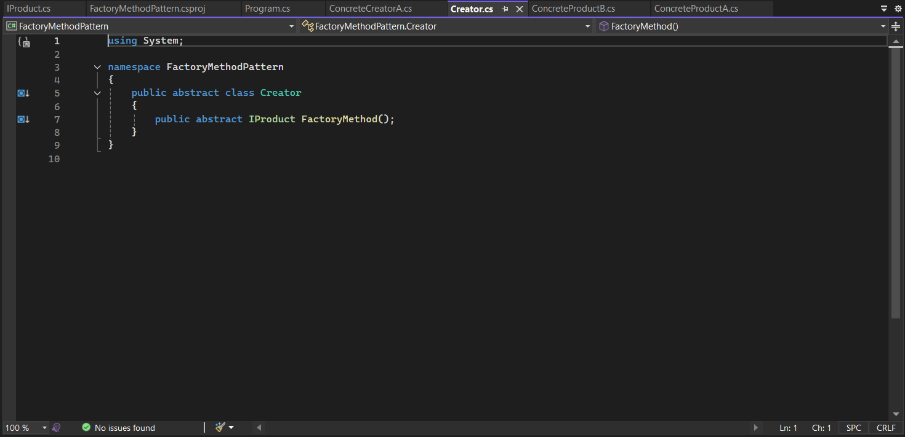

**ConcreteProductB.cs**

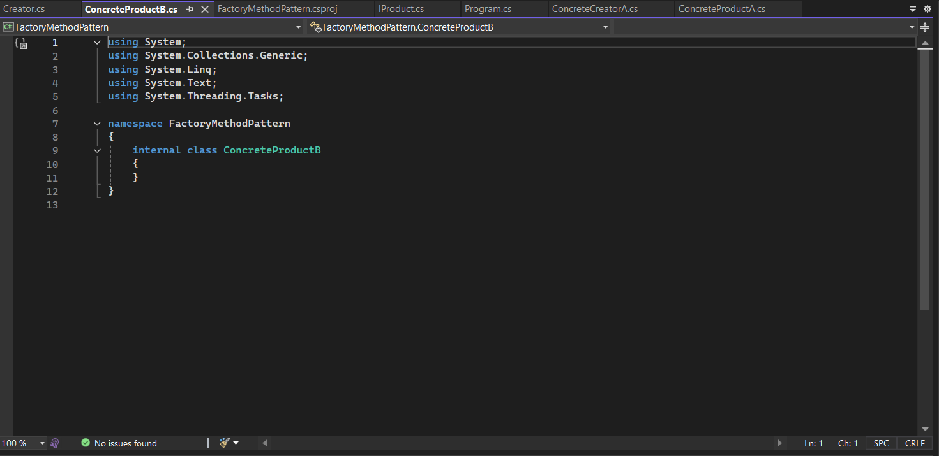

**ConcreteProductA.cs**

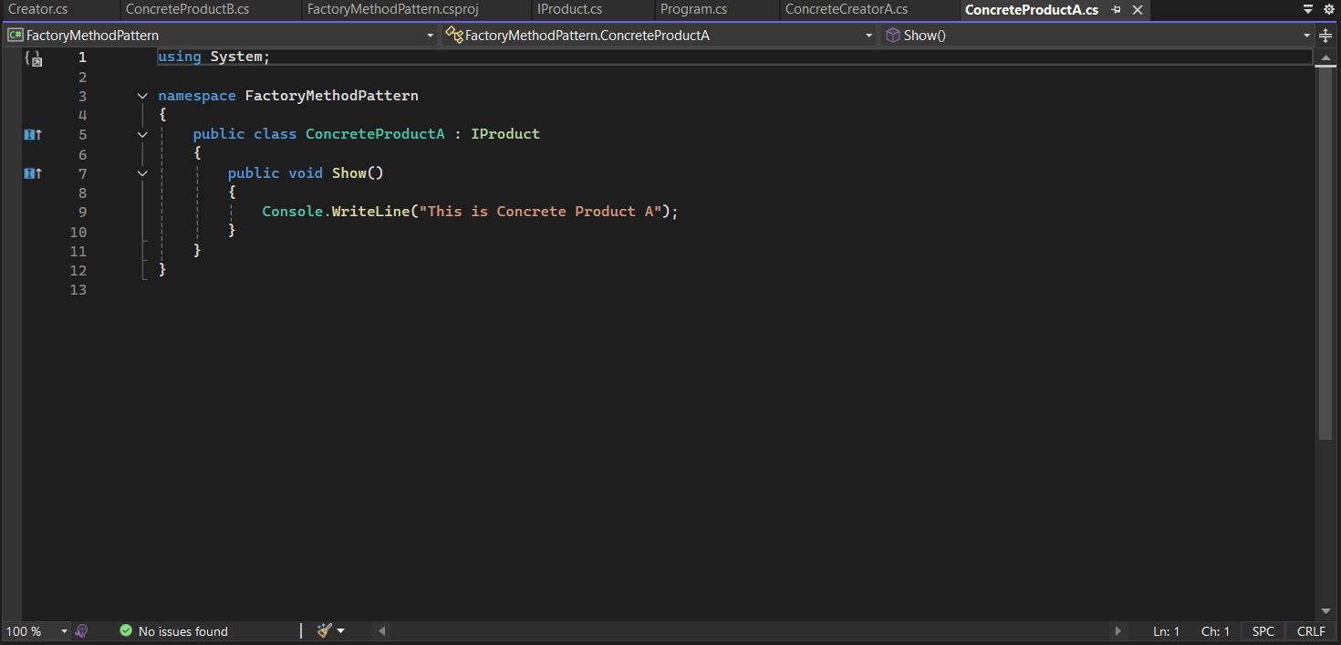

**ConcreteCreatorB.cs**

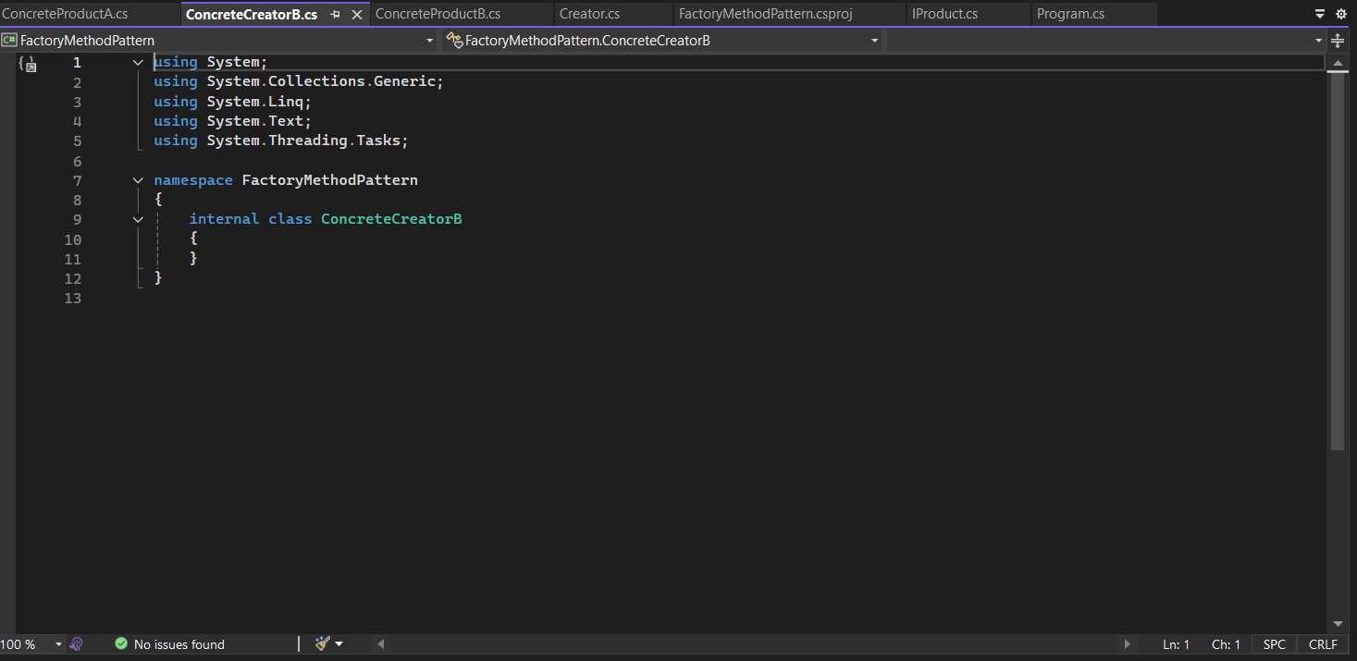

**ConcreteCreatorA.cs**

